**Objective 9**

**Q1.WAP to insert image using layout in tkinter?**

**Code:**

from tkinter import *

top =Tk()

Label(top,text="image ").pack()

#ipadx internal padding of x and ipday

k=PhotoImage(file="496002.png")

Label(top,image=k ,pady=10).pack()

top.mainloop()

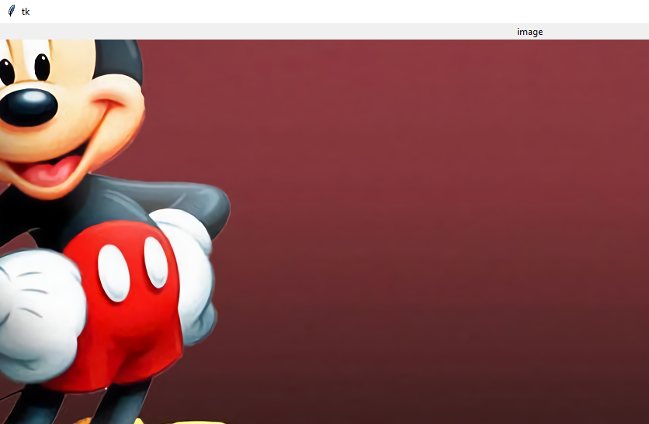

**Q 2 .WAP to make GUI calculator to perform simple calculation using**

**tkinter ?**

**code :**

from tkinter import *

from tkinter import messagebox

#pring on label by this empty string and strinVar() function

val=""

# operators code

a=0

operator=""

# working of opeartion like + and minus

# +

def bplus_click():

global val

global operator

global a

# converting integer from string

a=int(val)

operator="+"

val=val+"+"

#putting value on label

data.set(val)

# -

def bminus_click():

global val

global operator

global a

# converting integer from string

a=int(val)

operator="-"

val=val+"-"

#putting value on label

data.set(val)

def bmul_click():

global val

global operator

global a

# converting integer from string

a=int(val)

operator="*"

val=val+"*"

#putting value on label

data.set(val)

def bdiv_click():

global val

global operator

global a

# converting integer from string

a=int(val)

operator="/"

val=val+"/"

#putting value on label

data.set(val)

#working code

def b1_click():

global val

val=val+"1"

#putting value on label

data.set(val)

def b0_click():

global val

val=val+"0"

data.set(val)

def b2_click():

global val

val=val+"2"

data.set(val)

def b3_click():

global val

val=val+"3"

data.set(val)

def b4_click():

global val

val=val+"4"

data.set(val)

def b5_click():

global val

val=val+"5"

data.set(val)

def b6_click():

global val

val=val+"6"

data.set(val)

def b7_click():

global val

val=val+"7"

data.set(val)

def b8_click():

global val

val=val+"8"

data.set(val)

def b9_click():

global val

val=val+"9"

data.set(val)

def bclear():

global val

global operator

global a

a=0

# converting integer from string

#a=int(val)

operator=""

val=""

#putting value on label

data.set(val)

def bdot():

global val

global operator

global a

a=0

# converting integer from string

k=float(val)

a=int(k)

val=val+"."

#putting value on label

data.set(val)

# LAST result function

def result():

global val

global operator

global a

val2=val

#putting value on label

data.set(val)

if(operator=="+"):

# eg 13 +12 so value.split(divides them in two parts and at index 1 there is second value which we convert into integer)

c = int(val2.split("+")[1])

# operation pefroming from a and splited value

c=c+a

data.set(c)

val=str(c)

if(operator=="-"):

# eg 13 +12 so value.split(divides them in two parts and at index 1 there is second value which we convert into integer)

c = int(val2.split("-")[1])

# operation pefroming from a and splited value

c=c+a

data.set(c)

val=str(c)

if(operator=="*"):

# eg 13 +12 so value.split(divides them in two parts and at index 1 there is second value which we convert into integer)

c = int(val2.split("*")[1])

# operation pefroming from a and splited value

c=c*a

data.set(c)

val=str(c)

if(operator=="/"):

# eg 13 +12 so value.split(divides them in two parts and at index 1 there is second value which we convert into integer)

c = int(val2.split("/")[1])

if(c==0):

val=""

data.set("INFINITY")

else:

c=c/a

data.set(c)

val=str(c)

top = Tk()

top.geometry("350x400+300+300")

top.resizable()

top.title(" Harshit's simple calculator")

# one lable

data= StringVar()

l=Label(top,text="0",textvariable=data,anchor=SE,font=("verdana",22), background="#ffffff",fg="#000000")

l.pack(expand=True,fill="both")

# using frame 1

frame1=Frame(top)

frame1.pack(expand=True ,fill="both")

b1=Button(frame1,text="1", activebackground="grey", activeforeground="white",font=("verdana",22) ,relief=GROOVE,border=0,command=b1_click)

b1.pack(side=LEFT,expand=True,fill="both" )

b2=Button(frame1,text="2", activebackground="grey", activeforeground="white",font=("verdana",22,),relief=GROOVE,border=0,command=b2_click)

b2.pack(side=LEFT,expand=True,fill="both")

b3=Button(frame1,text="3", activebackground="grey", activeforeground="white",font=("verdana",22),relief=GROOVE,border=0,command=b3_click)

b3.pack(side=LEFT,expand=True,fill="both")

b4=Button(frame1,text="+", activebackground="grey", activeforeground="white",font=("verdana",22),relief=GROOVE,border=0,command=bplus_click)

b4.pack(side=LEFT,expand=True,fill="both")

# using frame 2

frame2=Frame(top)

frame2.pack(expand=True ,fill="both")

b5=Button(frame2,text="4",activebackground="grey", activeforeground="white",font=("verdana",22),relief=GROOVE,border=0,command=b4_click)

b5.pack(side=LEFT,expand=True,fill="both")

b6=Button(frame2,text="5",activebackground="grey", activeforeground="white",font=("verdana",22),relief=GROOVE,border=0,command=b5_click)

b6.pack(side=LEFT,expand=True,fill="both")

b7=Button(frame2,text="6",activebackground="grey", activeforeground="white",font=("verdana",22),relief=GROOVE,border=0,command=b6_click)

b7.pack(side=LEFT,expand=True,fill="both")

b8=Button(frame2,text="-",activebackground="grey", activeforeground="white",font=("verdana",22),relief=GROOVE,border=0,command=bminus_click)

b8.pack(side=LEFT,expand=True,fill="both")

# using frame 3

frame3=Frame(top)

frame3.pack(expand=True ,fill="both")

b9=Button(frame3,text="7",activebackground="grey", activeforeground="white",font=("verdana",22),relief=GROOVE,border=0,command=b7_click)

b9.pack(side=LEFT,expand=True,fill="both")

b10=Button(frame3,text="8",activebackground="grey", activeforeground="white",font=("verdana",22),relief=GROOVE,border=0,command=b8_click)

b10.pack(side=LEFT,expand=True,fill="both")

b11=Button(frame3,text="9",activebackground="grey", activeforeground="white",font=("verdana",22),relief=GROOVE,border=0,command=b9_click)

b11.pack(side=LEFT,expand=True,fill="both")

b12=Button(frame3,text="*",activebackground="grey", activeforeground="white",font=("verdana",22),relief=GROOVE,border=0,command=bmul_click)

b12.pack(side=LEFT,expand=True,fill="both")

# using frame 4

frame4=Frame(top)

frame4.pack(expand=True ,fill="both")

b13=Button(frame4,text="0",activebackground="grey", activeforeground="white",font=("verdana",22),relief=GROOVE,border=0,command=b0_click)

b13.pack(side=LEFT,expand=True,fill="both")

b16=Button(frame4,text="C",activebackground="grey", activeforeground="white",font=("verdana",22),relief=GROOVE,border=0,command=bclear)

b16.pack(side=LEFT,expand=True,fill="both")

b15=Button(frame4,text="=",activebackground="grey", activeforeground="white",font=("verdana",22),relief=GROOVE,border=0,command=result)

b15.pack(side=LEFT,expand=True,fill="both")

b16=Button(frame4,text="/",activebackground="grey", activeforeground="white",font=("verdana",22),relief=GROOVE,border=0,command=bdiv_click)

b16.pack(side=LEFT,expand=True,fill="both")

#b17=Button(frame4,text=".",activebackground="grey", activeforeground="white",font=("verdana",22),relief=GROOVE,border=0,command=bdot)

#b17.pack(side=LEFT,expand=True,fill="both")

**Output:**

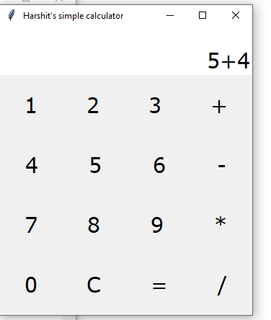

**SECOND OUTPUT**

